Software Requirements Specification (SRS)

Project: College Timetable Generation System (CTGS)
Version: 1.0
Date: 08-10-2026
Status: Draft for review

Revision history
Version | Date | Change summary | Approval
1.0 | 08-10-2026 | First complete SRS with use-case diagrams, requirements and RTM embedded | Pending

Approvals
Role | Signature / Email | Date
Course Coordinator
Project Guide / Faculty Mentor
Team Lead

Table of Contents
1. Introduction
2. Overall description
3. External interfaces
4. System features (detailed)
5. Non-functional requirements (detailed)
5.1 Security (objectives and requirements)
6. Quality attributes & Acceptance tests
7. System models and diagrams (UML Use-Case diagrams)
8. Requirements Traceability Matrix (RTM)

1. Introduction

1.1 Purpose
This document is the Software Requirements Specification (SRS) for the College Timetable Generation System (CTGS). CTGS automatically assigns subjects, faculty, classrooms, laboratories and student sections to the available time slots of a college week while satisfying scheduling constraints and avoiding conflicts. The SRS defines the functional and non-functional requirements, external interfaces, security requirements and verification criteria that the Software Architecture and Design Specification (SAD) and the Software Test Plan (STP) are built on.

1.2 Scope
In scope. Maintaining the academic master data needed for scheduling (departments, programmes, courses, faculty, rooms, sections, lab batches, time grid); capturing hard and soft constraints, availability and locked sessions; automatic generation of a weekly, conflict-free timetable; conflict detection, manual editing, versioning and approval; publishing and viewing timetables for sections, faculty and rooms; export, reports, notifications, audit trail and administration.
Out of scope (version 1.0). Examination timetabling, student attendance, fee or payroll processing, student-level elective seat allocation (electives are modelled as groups that run in parallel), week-by-week variations of the timetable, and native mobile apps. Institution ERP internals are not implemented; CTGS only exchanges CSV/REST data with them.

1.3 Audience
Developers, QA engineers, the Timetable Coordinators and Heads of Department who will operate the system, system administrators and IT operations staff, security reviewers, and course instructors or evaluators assessing the project.

1.4 Definitions
Term | Meaning
CTGS | College Timetable Generation System (this product)
SRS / SAD / STP / RTM | Software Requirements Specification / Software Architecture and Design Specification / Software Test Plan / Requirements Traceability Matrix
FR / NFR / SR / SO | Functional requirement / Non-functional requirement / Security requirement / Security objective
Section | A group of students taught together (for example CSE-5A); the unit for which a timetable is produced
Batch | A sub-group of a section used for laboratory sessions so that no batch exceeds a lab's capacity
Course offering | A course delivered to one section in one academic term
Teaching assignment | A faculty member assigned to a course offering (or one of its batches) for Lecture, Tutorial or Practical hours
L-T-P | Weekly Lecture, Tutorial and Practical hours of a course
Session | One scheduled class: a course, faculty, room, section or batch, a day and one or more consecutive periods
Slot / Period / Time grid | A (day, period) cell of the week / one teaching period / the configured days, periods and breaks of the week
Hard constraint (HC) | A rule that must never be violated by a timetable (for example a faculty cannot be in two rooms at once)
Soft constraint (SC) | A preference that is optimised using a weight; violating it lowers the quality score but does not make the timetable invalid
CSP / CP-SAT | Constraint Satisfaction Problem / the constraint-programming solver of Google OR-Tools used by the scheduling engine
Coordinator / HoD | Timetable Coordinator (prepares timetables) / Head of Department (approves and publishes)
RBAC, SSO, OIDC | Role-based access control, single sign-on, OpenID Connect
TLS, HSTS, CSRF, XSS | Transport Layer Security, HTTP Strict Transport Security, cross-site request forgery, cross-site scripting
RPO / RTO | Recovery point objective / recovery time objective
WCAG, SUS | Web Content Accessibility Guidelines / System Usability Scale
CSV, XLSX, PDF, ICS | Comma-separated values, Excel workbook, Portable Document Format, iCalendar file formats
API, UI, PII | Application programming interface, user interface, personally identifiable information

1.5 References
- IEEE Std 830-1998 and ISO/IEC/IEEE 29148:2018 - requirements specification practice
- Google OR-Tools CP-SAT solver documentation (constraint programming)
- OWASP Application Security Verification Standard (ASVS) and OWASP Top 10
- W3C Web Content Accessibility Guidelines (WCAG) 2.1
- CTGS Software Architecture and Design Specification v1.0 and Software Test Plan v1.0 (companion documents)

2. Overall description

2.1 Product perspective
CTGS is a web-based, multi-user system used inside a college. Browsers connect to a stateless API service; long-running timetable generation is executed by separate scheduling workers that read the master data and constraints from a relational database, solve the scheduling problem as a constraint-satisfaction and optimisation problem, validate the result with an independent validator, and store it as a versioned timetable. The system optionally integrates with the institution's single sign-on (OIDC), mail relay (SMTP) and ERP/student information system (CSV or REST) but does not depend on them to schedule.

2.2 Major product functions (detailed)
- Authenticate users and enforce role- and department-based access
- Maintain master data: academic structure, courses, faculty and qualifications, rooms and labs, sections and lab batches, time grid, teaching assignments; bulk import from CSV/XLSX
- Capture constraints: hard-constraint catalogue, soft-constraint weights, faculty availability and preferences, room blocked windows, locked sessions, elective groups and combined classes
- Check data feasibility, then automatically generate a conflict-free timetable that assigns subject, faculty, classroom or laboratory and section/batch to each slot, optimising soft constraints
- Allocate faculty automatically where teaching assignments are left open, balancing workload
- Diagnose infeasible input and return best partial results with suggested remedies
- Detect conflicts, edit timetables manually with instant checks, suggest substitutes after disruption, keep versions, compare and roll back
- Approval and publishing workflow; notifications on publish and change
- Views for sections/batches, faculty and rooms; exports (PDF, XLSX, ICS); reports on workload, utilisation and unscheduled sessions
- Audit trail, backup/restore and term cloning

2.3 User roles and characteristics (expanded)
Role | Characteristics | Main privileges
Administrator | IT or academic-office staff; manages the institution-wide data and users; moderate technical skill. | Manage users and roles, master data, time grid, audit log, backup and term cloning; may approve/publish; view everything.
Timetable Coordinator | Department staff who prepare the timetable; knows the courses and faculty well, limited technical skill; needs clarity and control. | Maintain data and constraints for the assigned departments, run feasibility checks and generation, edit, version, submit for approval.
Department Head (HoD) | Senior faculty; reviews the result and signs it off; occasional user. | Review timetables and reports, approve and publish, approve change requests.
Faculty | Teaching staff; wants to see their schedule and state availability and preferences; non-technical. | View published timetables; enter own availability and preferences; export own timetable.
Student | Section or batch member; uses the system mainly from a phone; non-technical. | View and export the published timetable of own section/batch; receive notifications.

2.4 Operating environment
Server side: Linux containers (API service, scheduling workers, Redis queue) and PostgreSQL 16 on an institution data centre or private cloud; reference machine for the scheduling worker is 8 vCPU, 16 GB RAM, SSD storage. Client side: latest two major versions of Chrome, Edge, Firefox and Safari on desktop, tablet or phone (minimum width 360 px for viewing). Campus network or VPN access to the system; UPS-backed servers and daily backups.

2.5 Constraints
- Scheduling quality: a published timetable must contain no hard-constraint violation (see section 4.3)
- Security and privacy: TLS 1.2+ everywhere, RBAC, protection of faculty and student data (institution privacy policy)
- Use of open-source components only (Python, OR-Tools, PostgreSQL, Redis, React) to avoid licence cost
- The scheduling problem is computationally hard; response time targets are stated for the reference datasets in section 5
- Academic calendar rules (working days, periods, breaks) are institution-specific and must be configurable, not hard-coded

2.6 Assumptions and dependencies
- Courses, faculty, rooms and sections are provided by the institution (manually, by CSV/XLSX import or from the ERP) before generation
- One academic term is scheduled at a time; the timetable repeats every week of the term
- Faculty weekly load and qualification lists are agreed with the HoD before scheduling
- An SMTP relay is available for email; SSO is optional - local accounts are supported

3. External interface requirements

3.1 User interfaces
Responsive web UI with a role-based menu and a task-oriented workflow: Data, Constraints, Generate, Review/Edit, Approve, Views, Reports. The timetable editor is a weekly grid (days x periods) with drag-and-drop and a keyboard alternative ("Move to..." dialog). Conflicts are shown with an icon and text, never by colour alone. Accessibility: WCAG 2.1 AA, keyboard operation, screen-reader labels, high-contrast theme, scalable fonts. Language: English (UI text externalised for later translation).

3.2 Hardware interfaces
- CTGS has no special hardware. Users need a device with a modern web browser and network access.
- Servers: x86-64 virtual machines or containers; scheduling worker nodes with 8 vCPU / 16 GB RAM (reference); SSD storage for the database and backups.
- Optional: network printers for printing exported PDF timetables.

3.3 Software interfaces
- Database: PostgreSQL 16 over TLS (SQL via SQLAlchemy).
- Job queue: Redis for solve and notification jobs.
- Solver: Google OR-Tools CP-SAT embedded in the scheduling worker (in-process library call).
- SSO (optional): OpenID Connect / OAuth2 identity provider for login.
- Mail: SMTP relay (TLS) for notification email.
- ERP / SIS (optional): CSV files or REST/JSON for importing faculty, courses and sections.
- Files: CSV/XLSX import; PDF, XLSX and ICS (iCalendar) export; public REST API documented with OpenAPI 3.

3.4 Communications
- HTTPS with TLS 1.2 or higher for all browser-to-server traffic; HSTS enabled; TLS also on database, Redis and SMTP links.
- REST over JSON (OpenAPI 3); server-sent events or polling for job progress.
- Retry with exponential back-off for email delivery (max 3 attempts); idempotent job submission keys to avoid duplicate generation runs.
- Import and export files up to 10 MB; larger data sets are imported in several files.

4. System features (detailed)
Each requirement below includes acceptance criteria and reference test cases (full test cases are in the Software Test Plan). IDs follow TT-F-###; non-functional IDs follow TT-NF-###, security IDs TT-SR-###. Priority: High = must have for release, Medium = should have, Low = could have.
Requirement summary: 40 functional requirements, 12 non-functional requirements, 3 security objectives and 10 security requirements (the course minimums are 15 / 5 / 2 / 5).

4.1 Authentication and Access Control
Description: Authenticate users, assign one of five roles and enforce what each role may do.
Req ID | Requirement (shall...) | Type | Priority | Source / Stakeholder | Acceptance criteria / Test case ref | Comments / Dependencies
TT-F-001 | The system shall authenticate users with institutional credentials (username and password, or SSO through OAuth2/OIDC where configured) and assign exactly one role: Administrator, Timetable Coordinator, Department Head (HoD), Faculty or Student. | Functional | High | Security / Administration | AC-TT-F-001: Valid credentials create a session with the correct role and menus; invalid credentials are rejected with one generic message (no user enumeration).  Test: TC-Auth-01, TC-Auth-02 | Module: AuthModule  DS-Auth-01
TT-F-002 | The system shall enforce role-based and department-scoped authorisation on every operation (deny by default): only Administrators and Coordinators may change data or run generation; Faculty and Students have read-only access to published timetables. | Functional | High | Security | AC-TT-F-002: Every unauthorised call returns HTTP 403 and changes no data; 0 bypasses in the role-by-endpoint test matrix.  Test: TC-Auth-03 | Module: AuthModule  DS-Auth-02
TT-F-003 | The system shall lock an account for 15 minutes after 5 consecutive failed logins, record an audit event, and expire sessions after 30 minutes of inactivity. | Functional | Medium | Security | AC-TT-F-003: 6th attempt within the lock window is refused even with the correct password; idle session returns 401 after 30 min.  Test: TC-Auth-04, TC-Auth-05 | Module: AuthModule  DS-Auth-01
TT-F-004 | The system shall let an Administrator create, update and disable users, assign roles, and scope Coordinators and HoDs to one or more departments. | Functional | Medium | Administration | AC-TT-F-004: A disabled user cannot log in; a Coordinator scoped to Department A cannot modify Department B data.  Test: TC-Auth-06 | Module: AuthModule  DS-Auth-03

4.2 Master Data Management
Description: Maintain the academic data the scheduler needs: structure, courses, faculty, rooms, sections, time grid and teaching assignments.
Req ID | Requirement (shall...) | Type | Priority | Source / Stakeholder | Acceptance criteria / Test case ref | Comments / Dependencies
TT-F-010 | The system shall let authorised users create, view, update and delete the academic structure: departments, programmes, semesters and academic terms, with exactly one active term at a time. | Functional | High | Administration | AC-TT-F-010: Entities are saved with unique names per parent; deleting an entity that has dependants is blocked with a message listing them.  Test: TC-MD-01 | Module: MasterDataModule  DS-Data-01
TT-F-011 | The system shall manage courses with code, title, type (Theory, Lab, Elective, Project), credits, weekly Lecture-Tutorial-Practical (L-T-P) hours, required room type and semester. | Functional | High | Coordinator / Academics | AC-TT-F-011: Duplicate codes, negative or non-integer hours are rejected with field-level errors; a valid course is retrievable by code.  Test: TC-MD-02 | Module: MasterDataModule  DS-Data-01
TT-F-012 | The system shall manage faculty with department, designation, minimum and maximum weekly load, maximum periods per day, and a qualification list of courses they can teach. | Functional | High | Coordinator / HR | AC-TT-F-012: A faculty record with max load below min load is rejected; qualification list is stored and used by HC-08.  Test: TC-MD-03 | Module: MasterDataModule  DS-Data-01
TT-F-013 | The system shall manage rooms with name, building, type (Classroom, Lab, Seminar hall), capacity and equipment tags. | Functional | High | Administration / Estates | AC-TT-F-013: Capacity must be a positive integer; rooms can be filtered by type, capacity and equipment.  Test: TC-MD-04 | Module: MasterDataModule  DS-Data-01
TT-F-014 | The system shall manage student sections and lab batches, and shall automatically split a section into the minimum number of near-equal batches so that no batch exceeds the configured lab capacity. | Functional | High | Coordinator | AC-TT-F-014: Section of 62 students with lab limit 30 gives 3 batches (21, 21, 20); batch sizes differ by at most 1 and never exceed the limit.  Test: TC-MD-05, TC-MD-06 | Module: MasterDataModule  DS-Data-02
TT-F-015 | The system shall let authorised users configure the time grid: working days, periods per day, period start/end times and fixed breaks. | Functional | High | Administration | AC-TT-F-015: A 5-day, 8-period grid with lunch after period 4 is saved; changing the grid while a published timetable exists is blocked with a warning.  Test: TC-MD-07 | Module: MasterDataModule  DS-Data-01
TT-F-016 | The system shall import master data in bulk from CSV/XLSX files, validate every row, and offer an atomic (all-or-nothing) mode and a row-level error report. | Functional | High | Coordinator | AC-TT-F-016: A 200-row valid file creates 200 records; a file with 5 bad rows in atomic mode imports nothing and reports row, column and reason for each error.  Test: TC-MD-08, TC-MD-09 | Module: ImportModule  DS-Data-03
TT-F-017 | The system shall let a Coordinator define course offerings per section and teaching assignments (course, section/batch, faculty), either fully assigned or left unassigned for automatic allocation. | Functional | High | Coordinator | AC-TT-F-017: An assignment of a faculty member who is not qualified for the course is rejected; unassigned offerings are listed for allocation.  Test: TC-MD-10 | Module: MasterDataModule  DS-Data-04

4.3 Constraint Configuration
Description: Capture hard and soft scheduling constraints, availability, locks and elective/combined classes. The catalogue of constraints is listed below.
Constraint catalogue. Hard constraints must hold in every saved timetable. Soft constraints are optimised with the weight (0-10) chosen per run; default weights are shown.
Table 1: Hard constraints (HC)
ID | Constraint | Rule | Mandatory
HC-01 | Faculty clash | A faculty member teaches at most one session in any time slot. | Yes
HC-02 | Room clash | A room hosts at most one session in any time slot (except a declared combined class that shares the room). | Yes
HC-03 | Section / batch clash | A section attends at most one session per slot; a section-level session blocks all of its lab batches, and a batch session blocks only that batch. | Yes
HC-04 | Room suitability | Room type matches the session (classroom, lab category) and room capacity is at least the group size. | Yes
HC-05 | Required weekly hours | Every course offering receives exactly its Lecture, Tutorial and Practical hours per week. | Yes
HC-06 | Lab continuity | A practical session occupies consecutive periods (default 2, configurable 2-3) inside one half-day and never spans a break. | Yes
HC-07 | Faculty availability and load | No session in a slot the faculty marked unavailable; periods per day and per week stay within the faculty's limits. | Yes
HC-08 | Qualification | Only faculty mapped to a course (qualification list) may be assigned to it. | Yes
HC-09 | Locked sessions | Sessions locked or pre-assigned by the coordinator keep their slot, room and faculty. | Yes
HC-10 | Elective groups and combined classes | All courses of an elective group, and all sections of a combined class, are scheduled in the same slots. | Yes
HC-11 | Room availability | No session in a room during a blocked window (maintenance, examination hold). | Yes

Table 2: Soft constraints (SC)
ID | Constraint | Preference | Default weight
SC-01 | Compact section day | Minimise idle gaps in a section's day. | 5
SC-02 | Compact faculty day | Minimise idle gaps in a faculty member's day. | 4
SC-03 | Spread course over the week | At most 2 periods of the same course per day; spread sessions over different days. | 6
SC-04 | Faculty preferences | Honour preferred slots and requested days off. | 3
SC-05 | Balanced daily load | Avoid very heavy and very light days for a section (target 5-6 periods/day). | 4
SC-06 | Time-of-day fit | Prefer theory in the morning and labs in the afternoon. | 2
SC-07 | Few room changes | Prefer the section's home classroom and avoid back-to-back room changes. | 2
SC-08 | Balanced faculty load | Spread a faculty member's periods evenly across working days. | 3

Req ID | Requirement (shall...) | Type | Priority | Source / Stakeholder | Acceptance criteria / Test case ref | Comments / Dependencies
TT-F-020 | The system shall provide the catalogue of hard constraints HC-01 to HC-11; mandatory hard constraints cannot be disabled and optional ones can be switched per run. | Functional | High | Coordinator | AC-TT-F-020: Attempting to disable HC-01 is refused; toggling an optional constraint is saved and shown in the run summary.  Test: TC-Con-01 | Module: ConstraintModule  DS-Cons-01
TT-F-021 | The system shall let a Coordinator set a weight from 0 to 10 for each soft constraint SC-01 to SC-08 per generation run. | Functional | Medium | Coordinator | AC-TT-F-021: Weights outside 0-10 are rejected; the weights used are stored with the generated timetable.  Test: TC-Con-02 | Module: ConstraintModule  DS-Cons-01
TT-F-022 | The system shall capture faculty availability and preferences: unavailable slots, preferred slots and requested days off. | Functional | High | Faculty / Coordinator | AC-TT-F-022: No session is generated for a faculty member in a slot marked unavailable; preferences affect only soft penalties.  Test: TC-Con-03 | Module: ConstraintModule  DS-Cons-02
TT-F-023 | The system shall capture room unavailability windows (maintenance, examinations) and exclude them from scheduling. | Functional | Medium | Administration | AC-TT-F-023: No session is placed in a room during a blocked window.  Test: TC-Con-04 | Module: ConstraintModule  DS-Cons-02
TT-F-024 | The system shall allow a Coordinator to lock or pre-assign a session to a given slot, room and/or faculty, and shall honour locked sessions in every generation. | Functional | High | Coordinator | AC-TT-F-024: A session locked to Monday period 1 in Room R-101 is unchanged after generation and regeneration.  Test: TC-Con-05 | Module: ConstraintModule  DS-Cons-03
TT-F-025 | The system shall let a Coordinator define elective groups and combined (cross-section) classes that must be scheduled in the same slots. | Functional | High | Coordinator / Academics | AC-TT-F-025: All courses in an elective group and all sections of a combined class occupy identical slots in the generated timetable.  Test: TC-Con-06 | Module: ConstraintModule  DS-Cons-04

4.4 Timetable Generation
Description: Automatically assign subjects, faculty, classrooms, laboratories and student sections to time slots while satisfying the constraints and avoiding conflicts.
Req ID | Requirement (shall...) | Type | Priority | Source / Stakeholder | Acceptance criteria / Test case ref | Comments / Dependencies
TT-F-030 | The system shall run a feasibility pre-check before generation and report data defects with severity, affected entity and suggested remedy (for example required hours exceeding available slots, faculty load above maximum, no room of the required type and capacity). | Functional | High | Coordinator | AC-TT-F-030: Seeded defects are each reported with entity and remedy; error-level defects block the run, warnings do not.  Test: TC-Gen-01, TC-Gen-02 | Module: SchedulerEngine  DS-Gen-01
TT-F-031 | The system shall automatically generate a timetable that assigns every required session to a day and period, a room or laboratory, a faculty member and a student section or lab batch. | Functional | High | Coordinator / Dean | AC-TT-F-031: On the Medium dataset 100% of required sessions are scheduled and each has all five attributes (course, faculty, room, section/batch, slot).  Test: TC-Gen-03 | Module: SchedulerEngine  DS-Gen-03
TT-F-032 | The system shall guarantee that a saved or published timetable has zero hard-constraint violations (faculty, room and section double-booking, capacity/type mismatch, availability) by checking every solution with an independent validator before saving. | Functional | High | Dean / Faculty / Students | AC-TT-F-032: Validator reports 0 violations for all generated timetables; a timetable with an injected double-booking is refused at save/publish.  Test: TC-Gen-04, TC-Gen-05, TC-Rel-01 | Module: SchedulerEngine, ValidationModule  DS-Gen-03, DS-Val-01
TT-F-033 | The system shall schedule laboratory sessions as contiguous blocks (default 2 periods, configurable up to 3) that do not span a break, in labs of the matching category, with parallel batches placed in different labs. | Functional | High | Academics | AC-TT-F-033: Every lab session has the configured number of consecutive periods in one half-day, in a suitable lab; no two parallel batches share a lab.  Test: TC-Gen-06 | Module: SchedulerEngine  DS-Gen-04
TT-F-034 | The system shall optimise the soft constraints according to the configured weights and report the total objective score with a per-constraint penalty breakdown. | Functional | Medium | Coordinator | AC-TT-F-034: Score breakdown sums to the total; a run with weights set to non-zero values scores better than the same run with all weights 0.  Test: TC-Gen-07 | Module: SchedulerEngine  DS-Gen-05
TT-F-035 | The system shall automatically allocate faculty to unassigned teaching assignments using qualification, load limits and preferences, balancing workload across faculty. | Functional | High | Coordinator / HoD | AC-TT-F-035: All allocations respect HC-08 and the maximum load; the spread between most and least loaded faculty of a department is within the configured tolerance.  Test: TC-Gen-08 | Module: SchedulerEngine  DS-Gen-02
TT-F-036 | The system shall, when no feasible timetable exists or the time limit is reached, return the best partial result with the list of unscheduled sessions, the conflicting constraints and suggested remedies. | Functional | High | Coordinator | AC-TT-F-036: Infeasible input yields status INFEASIBLE with a minimal conflicting set; a time-limited run returns scheduled sessions with 0 hard violations plus the unscheduled list.  Test: TC-Gen-09, TC-Gen-10 | Module: SchedulerEngine  DS-Gen-06
TT-F-037 | The system shall execute generation as an asynchronous job with status, progress, configurable time limit, cancellation and an optional random seed. | Functional | High | Coordinator / IT Ops | AC-TT-F-037: Job moves QUEUED, RUNNING, DONE with progress updates; cancel stops the run within 10 s; UI stays responsive meanwhile.  Test: TC-Gen-10, TC-Gen-11, TC-Gen-12, TC-Gen-13 | Module: SchedulerEngine  DS-Gen-07
TT-F-038 | The system shall support regenerating only the unlocked part of a timetable and generating up to 5 alternative timetables for comparison. | Functional | Medium | Coordinator | AC-TT-F-038: Locked sessions are unchanged after regeneration; N alternatives are each valid and differ in at least one session.  Test: TC-Gen-14, TC-Gen-15 | Module: SchedulerEngine  DS-Gen-08

4.5 Conflict Detection, Editing and Publishing
Description: Let coordinators refine generated timetables safely, manage versions and publish after approval.
Req ID | Requirement (shall...) | Type | Priority | Source / Stakeholder | Acceptance criteria / Test case ref | Comments / Dependencies
TT-F-040 | The system shall let a Coordinator move or swap sessions in a grid editor with instant conflict checking; moves that violate a hard constraint are blocked with the reason. | Functional | High | Coordinator | AC-TT-F-040: A valid move is applied and versioned; a move creating a faculty, room, capacity or availability conflict returns 409 with the violated constraint and is not applied; concurrent edits are detected.  Test: TC-Edit-01, TC-Edit-02, TC-Edit-08 | Module: TimetableModule  DS-Edit-01
TT-F-041 | The system shall produce a conflict report for any timetable listing the violated constraint, the entities and the slot involved. | Functional | High | Coordinator | AC-TT-F-041: A timetable with injected conflicts lists each one; a valid timetable shows an empty report.  Test: TC-Edit-03 | Module: ValidationModule  DS-Val-01
TT-F-042 | The system shall suggest ranked substitute faculty or rooms when a faculty member or room becomes unavailable after publication, and apply the choice with minimal change to the timetable. | Functional | Medium | Coordinator / Faculty | AC-TT-F-042: Only the affected sessions change; each suggestion passes the validator; ranking prefers qualified, free, least-loaded faculty.  Test: TC-Edit-04 | Module: TimetableModule  DS-Edit-02
TT-F-043 | The system shall keep versions of every timetable with statuses Draft, Under Review, Published and Archived, and support compare and rollback. | Functional | Medium | Coordinator / HoD | AC-TT-F-043: Compare lists added, removed and moved sessions; rollback restores the earlier version as a new draft.  Test: TC-Edit-05, TC-Edit-06 | Module: TimetableModule  DS-Edit-03
TT-F-044 | The system shall require HoD (or Administrator) approval to publish a timetable; a published version is immutable except through a controlled change request. | Functional | High | HoD / Dean | AC-TT-F-044: A Coordinator cannot publish without approval; edits to a published version are rejected unless a change request is approved.  Test: TC-Edit-07 | Module: TimetableModule  DS-Edit-04

4.6 Views, Reports, Export and Notifications
Description: Deliver timetables to students, faculty and administrators in useful forms.
Req ID | Requirement (shall...) | Type | Priority | Source / Stakeholder | Acceptance criteria / Test case ref | Comments / Dependencies
TT-F-050 | The system shall display the weekly timetable of a section or lab batch showing course, faculty, room and time for each period. | Functional | High | Students | AC-TT-F-050: A student sees only the published timetable of their own section/batch; every period shows the four attributes.  Test: TC-View-01 | Module: ReportModule  DS-Rep-01
TT-F-051 | The system shall display a faculty member's personal weekly timetable and total weekly load. | Functional | High | Faculty | AC-TT-F-051: Displayed sessions and load equal the database; free periods are visible.  Test: TC-View-02 | Module: ReportModule  DS-Rep-01
TT-F-052 | The system shall display the timetable and utilisation of a room or laboratory. | Functional | Medium | Administration / Estates | AC-TT-F-052: Utilisation % equals occupied slots divided by available slots.  Test: TC-View-03 | Module: ReportModule  DS-Rep-01
TT-F-053 | The system shall export timetables to PDF, XLSX and iCalendar (ICS). | Functional | Medium | Faculty / Students | AC-TT-F-053: Exported content matches the on-screen timetable; ICS events import into a calendar client as weekly recurring events with correct time and location.  Test: TC-View-04, TC-View-05 | Module: ReportModule  DS-Rep-02
TT-F-054 | The system shall generate reports for faculty workload, room utilisation, unscheduled sessions and soft-constraint penalties. | Functional | Medium | HoD / Dean | AC-TT-F-054: Report figures reconcile with direct database queries (0 mismatches on the Medium dataset).  Test: TC-Rep-01 | Module: ReportModule  DS-Rep-03
TT-F-055 | The system shall notify affected faculty and students by email and in-app message when a timetable is published or changed. | Functional | Medium | Faculty / Students | AC-TT-F-055: Only affected users are notified; failed email delivery is retried up to 3 times; no duplicate messages.  Test: TC-Ntf-01, TC-Ntf-02 | Module: NotifyModule  DS-Ntf-01

4.7 Audit and Administration
Description: Traceability of every change and operational safety nets.
Req ID | Requirement (shall...) | Type | Priority | Source / Stakeholder | Acceptance criteria / Test case ref | Comments / Dependencies
TT-F-060 | The system shall keep an audit trail of every create, update, delete, generate, approve and publish action with user, time and before/after values. | Functional | High | Security / Audit | AC-TT-F-060: Each action in a scripted scenario appears exactly once in the audit trail with correct values.  Test: TC-Aud-01 | Module: AuditModule  DS-Aud-01
TT-F-061 | The system shall support backup and restore of all data and cloning of a previous term's master data and constraint configuration into a new term. | Functional | Medium | IT Ops / Administration | AC-TT-F-061: Restore reproduces the data set exactly; a cloned term has new identifiers and the source term is unchanged.  Test: TC-Aud-02, TC-Aud-03 | Module: Platform (Ops)  DS-Ops-01

5. Non-functional requirements (detailed)
NFRs below are measurable and tied to test cases. IDs follow TT-NF-###. Performance targets use the following reference datasets and reference machine (8 vCPU, 16 GB RAM, SSD storage).
Dataset | Scope | Size | Used for
S (Small) | 1 programme-semester | 3 sections, 12 faculty, 10 rooms (3 labs), 40 slots/week | Functional / smoke tests
M (Medium) | 1 department | 20 sections, 40 faculty, 30 rooms (10 labs), 40 slots/week | Typical coordinator workload
L (Large) | Whole institution | 120 sections, 260 faculty, 160 rooms (60 labs), ~3,000 sessions/week | Scalability and stress tests

Req ID | Requirement | Category | Priority | Acceptance criteria / Measurement
TT-NF-001 | Generation time: on the reference machine the system shall return a feasible, optimised timetable for the Medium dataset in 5 minutes or less and for the Large dataset in 30 minutes or less. | Performance | High | Median of 3 runs: Medium <= 5 min, Large <= 30 min on 8 vCPU / 16 GB.  Test: TC-Perf-01, TC-Perf-02
TT-NF-002 | Responsiveness: 95% of non-generation API calls shall complete within 1 s and timetable grids shall render within 2 s; a conflict check on a manual move shall complete within 500 ms (95th percentile) with 100 concurrent users. | Performance | High | Load test with 100 virtual users: p95 API <= 1 s, grid render <= 2 s, conflict check p95 <= 500 ms.  Test: TC-Perf-03, TC-Perf-04
TT-NF-003 | Correctness: 100% of timetables saved or published shall have zero hard-constraint violations as verified by the independent validator. | Reliability / Correctness | High | 0 violations across Small, Medium, Large datasets and 200 random property-based instances.  Test: TC-Gen-04, TC-Rel-01
TT-NF-004 | Availability: the system shall be available 99.5% of the time per month between 07:00 and 21:00 IST on working days, excluding announced maintenance. | Availability | High | Monthly uptime report >= 99.5% from 1-minute synthetic probes.  Test: TC-OPS-01
TT-NF-005 | Scalability: the system shall support 200 concurrent read users, 10 concurrent coordinators and 3 queued generation jobs with no more than 20% degradation of NF-002 figures. | Scalability | Medium | Mixed-load test: latency increase <= 20%; extra jobs beyond the quota are rejected with a clear message.  Test: TC-Perf-05
TT-NF-006 | Usability: a trained Coordinator shall complete data import and the first successful generation within 2 hours, and the System Usability Scale (SUS) score shall be 70 or higher. | Usability | Medium | Study with 5 coordinators: median task time <= 2 h; mean SUS >= 70.  Test: TC-UX-01
TT-NF-007 | Accessibility: the user interface shall conform to WCAG 2.1 AA; the timetable editor shall be fully keyboard operable and conflicts shall be indicated by icon and text, not colour alone. | Accessibility | Medium | Automated (axe-core) and manual audit: 0 critical/serious issues; contrast >= 4.5:1.  Test: TC-UX-02
TT-NF-008 | Reproducibility: in reproducible mode, the same input data, constraints, seed and solver version shall give an identical timetable. | Reliability / Determinism | Medium | Two runs with equal inputs produce byte-identical normalised output.  Test: TC-Gen-12
TT-NF-009 | Maintainability: the system shall use a layered modular design; line coverage shall be 80% or higher for the scheduling engine and validator and static analysis shall report 0 critical issues at release. | Maintainability | Medium | CI quality gate shows coverage >= 80% and 0 critical findings.  Test: TC-Mnt-01
TT-NF-010 | Backup and recovery: automated daily backups shall give a Recovery Point Objective (RPO) of 24 h or less and a Recovery Time Objective (RTO) of 4 h or less. | Recoverability | High | Restore drill completes within 4 h with data loss <= 24 h.  Test: TC-OPS-02
TT-NF-011 | Compatibility: the web UI shall work on the latest two major versions of Chrome, Edge, Firefox and Safari, and viewing pages shall be usable from 360 px screen width. | Portability / Compatibility | Medium | Test matrix passes on 4 browsers x 2 versions; mobile viewport usable for viewing.  Test: TC-UX-03
TT-NF-012 | Audit retention: audit records shall be kept for at least 3 years, be tamper-evident, and a one-year range shall be retrievable within 30 s. | Audit / Data retention | Medium | Retention job keeps >= 3 years; 1-year query <= 30 s; chain verification detects tampering.  Test: TC-OPS-03

5.1 Security

5.1.1 Security Objectives
The following security objectives drive the security requirements in section 5.1.2.
ID | Objective | Description
SO-1 | Confidentiality | Protect personal and academic data (faculty preferences and workload, student sections, user accounts) from disclosure to unauthorised users.
SO-2 | Integrity and accountability | Ensure that only authorised users can create, change, approve or publish timetables and that every change is attributable and tamper-evident.
SO-3 | Availability | Protect the web application and the scheduling service from abuse and resource exhaustion so timetables can be produced and read when needed, especially at term start.

5.1.2 Security Requirements
Req ID | Requirement (shall...) | Type | Priority | Objectives | Acceptance criteria / Test case ref
TT-SR-001 | TLS 1.2 or higher shall be mandatory for all network connections (browser to server, server to database, server to mail relay); older protocols shall be refused and HSTS enabled. | Security | High | SO-1, SO-2 | TLS scan shows no SSL/TLS < 1.2 and HSTS present.  Test: TC-Sec-01
TT-SR-002 | Passwords shall be stored only as salted Argon2id (or bcrypt cost >= 12) hashes, with a minimum length of 12 characters; passwords shall never be logged. | Security | High | SO-1 | Database inspection shows only hashes; weak passwords rejected.  Test: TC-Sec-02
TT-SR-003 | Authorisation shall be enforced server-side on every endpoint with deny-by-default, department scoping and object-level checks that prevent insecure direct object reference. | Security | High | SO-1, SO-2 | No privilege-escalation or IDOR finding in the penetration test.  Test: TC-Auth-03, TC-Sec-03
TT-SR-004 | All input shall be validated and all output encoded; the system shall use parameterised queries, CSRF protection and a restrictive Content-Security-Policy. | Security | High | SO-1, SO-2 | OWASP ZAP and manual tests find no high-severity injection, XSS or CSRF issue.  Test: TC-Sec-04
TT-SR-005 | Access tokens shall be short-lived (<= 30 min), stored in HttpOnly, Secure, SameSite cookies, rotated on role change and revoked at logout. | Security | High | SO-1, SO-2 | Cookie flags verified; a token reused after logout returns 401.  Test: TC-Auth-05, TC-Sec-05
TT-SR-006 | Login and expensive endpoints shall be rate limited, each user shall be limited to 2 concurrent generation jobs, and solver workers shall run with CPU, memory and time limits. | Security | High | SO-3 | 30 login attempts/min returns 429; third concurrent job rejected; solver killed at the limit.  Test: TC-Sec-06
TT-SR-007 | Uploaded files shall be restricted to CSV/XLSX up to 10 MB, content-checked, and spreadsheet formula injection shall be neutralised on import and export. | Security | High | SO-1, SO-3 | Renamed executables and files over 10 MB are rejected; cells starting with = + - @ are escaped.  Test: TC-MD-09, TC-Sec-07
TT-SR-008 | The audit log shall be append-only and hash-chained, and logs shall never contain passwords, tokens or full personal data. | Security | High | SO-2 | Log scan finds no secrets; modifying an audit row breaks chain verification.  Test: TC-Aud-01, TC-Sec-08
TT-SR-009 | Secrets shall be kept in a secret store or environment variables outside source control, and dependencies shall be scanned so that no known critical vulnerability ships. | Security | Medium | SO-1, SO-2 | Secret scan finds 0 secrets; dependency audit shows 0 critical CVEs at release.  Test: TC-Sec-09
TT-SR-010 | Students shall see only their own section/batch and published data; faculty preferences and unavailability shall be visible only to the owner and Coordinators; exports shall omit contact details unless requested by an Administrator. | Security | High | SO-1 | Cross-user access attempts are denied; exports for non-admins contain no email/phone.  Test: TC-Sec-03, TC-Sec-10

6. Quality attributes & Acceptance tests
- Exit criteria for acceptance: all High-priority functional requirements are implemented and verified, no critical NFR or security failure remains open, every timetable produced in acceptance testing has zero hard-constraint violations, and the RTM shows all test cases passed.
- Acceptance test suites: Authentication and Access, Master Data, Constraints, Generation, Edit and Publish, Views/Reports/Notifications, Audit and Operations, Performance and Reliability, Usability and Accessibility, Security (table below).
Table 3: Quality attributes and how they are measured
Quality attribute | Measure | Requirement
Correctness | 0 hard-constraint violations in saved/published timetables | TT-NF-003, TT-F-032
Performance | Generation <= 5 min (M) / 30 min (L); p95 API <= 1 s; conflict check <= 500 ms | TT-NF-001, TT-NF-002
Availability and recovery | 99.5% uptime in working hours; RPO <= 24 h, RTO <= 4 h | TT-NF-004, TT-NF-010
Scalability | 200 readers, 10 coordinators, 3 queued jobs, <= 20% degradation | TT-NF-005
Usability and accessibility | SUS >= 70; task time <= 2 h; WCAG 2.1 AA | TT-NF-006, TT-NF-007
Reproducibility | Same input + seed => identical timetable (reproducible mode) | TT-NF-008
Maintainability | Coverage >= 80% on engine and validator; 0 critical static-analysis findings | TT-NF-009
Security | TLS 1.2+, RBAC, no high-severity web findings, audit integrity | TT-SR-001 ... TT-SR-010

Table 4: Acceptance test suites (details in the Software Test Plan)
Suite | Test cases | Range | Coverage
Authentication and Access | 6 | TC-Auth-01 ... TC-Auth-06 | 6 requirements
Master Data | 10 | TC-MD-01 ... TC-MD-10 | 9 requirements
Constraints | 6 | TC-Con-01 ... TC-Con-06 | 6 requirements
Generation | 15 | TC-Gen-01 ... TC-Gen-15 | 11 requirements
Edit and Publish | 8 | TC-Edit-01 ... TC-Edit-08 | 5 requirements
Views, Reports, Notifications | 8 | TC-View-01 ... TC-Ntf-02 | 6 requirements
Audit and Operations | 6 | TC-Aud-01 ... TC-OPS-03 | 6 requirements
Performance and Reliability | 6 | TC-Perf-01 ... TC-Rel-01 | 5 requirements
Usability, Accessibility, Maintainability | 4 | TC-UX-01 ... TC-Mnt-01 | 4 requirements
Security | 10 | TC-Sec-01 ... TC-Sec-10 | 10 requirements
Total | 79 |  | 62 requirements covered

7. System models and diagrams

7.1 UML Use-Case diagrams
Three use-case diagrams cover the system: setup and configuration, generation and publishing, and viewing, reporting and audit. Use cases are numbered UC-01 to UC-25; the table at the end of this section links each use case to its requirements. Every use case except UC-01 requires an authenticated session (UC-01).
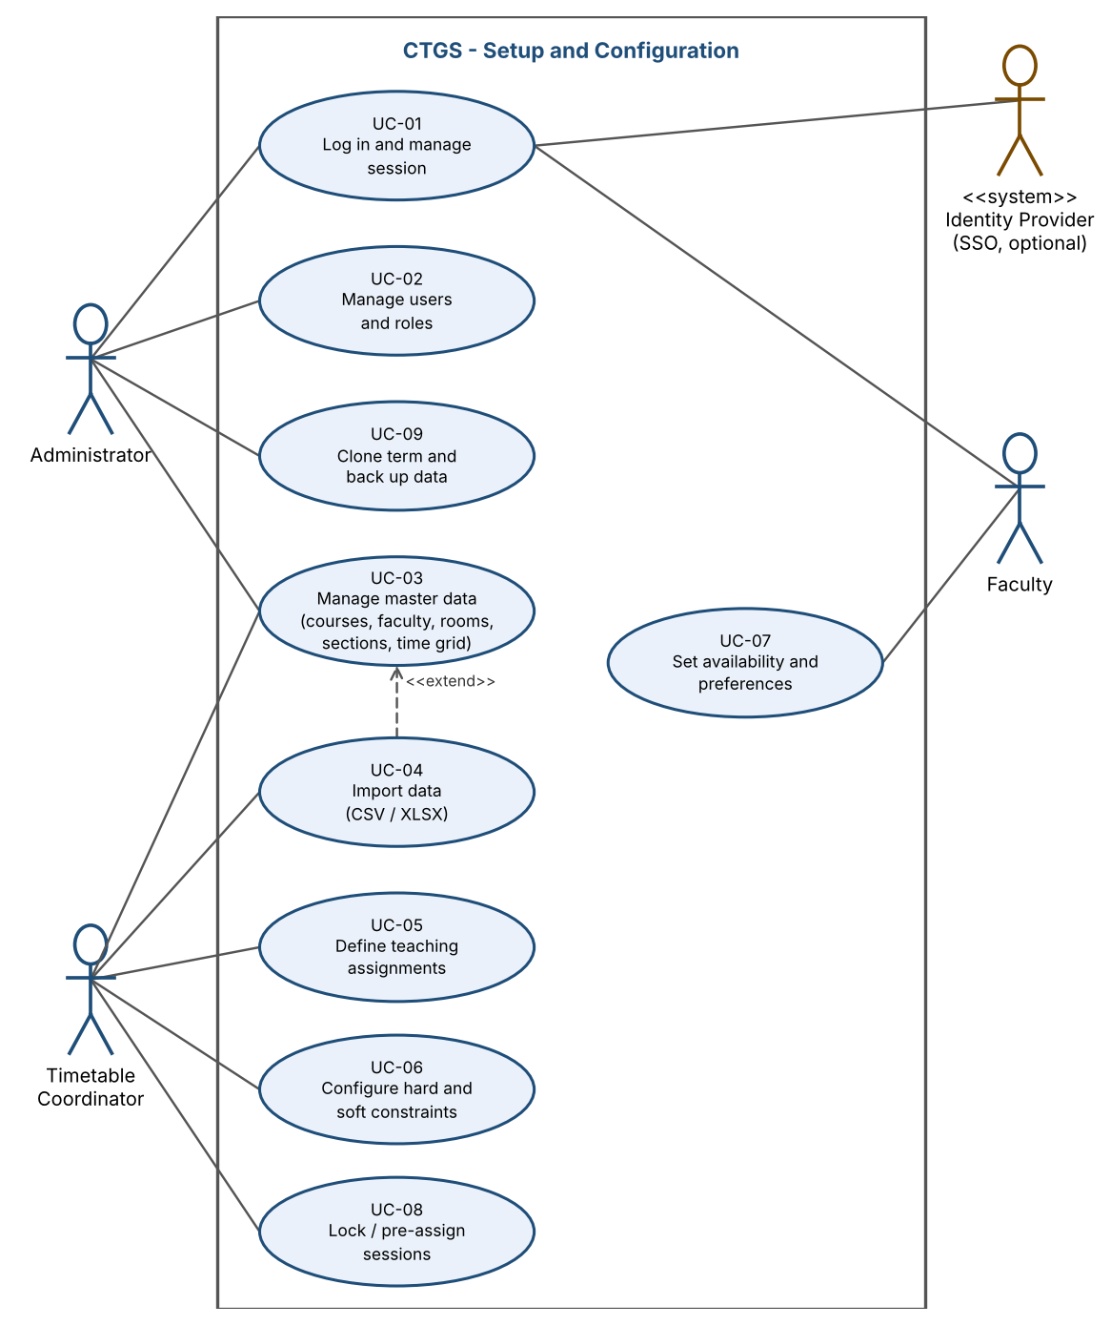
Figure 1: Use-case diagram 1 - Setup and configuration (UC-01 to UC-09)
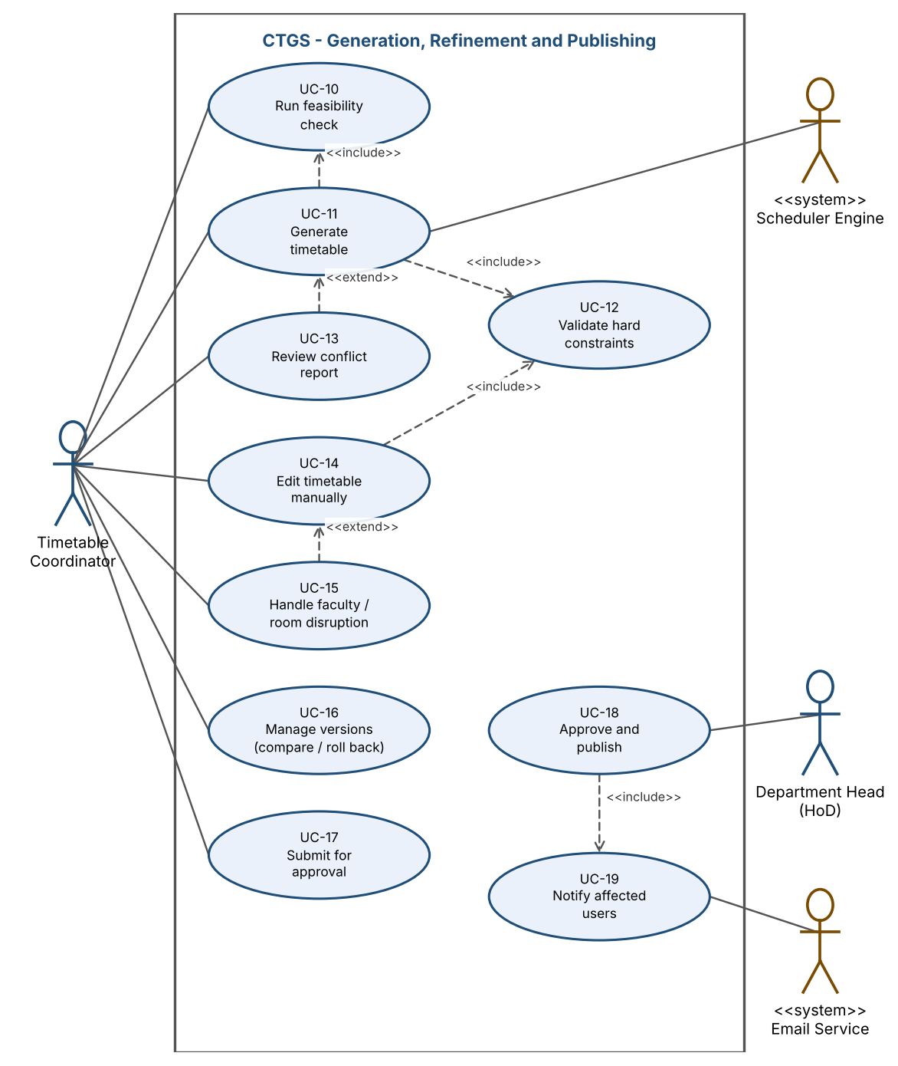
Figure 2: Use-case diagram 2 - Generation, refinement and publishing (UC-10 to UC-19)
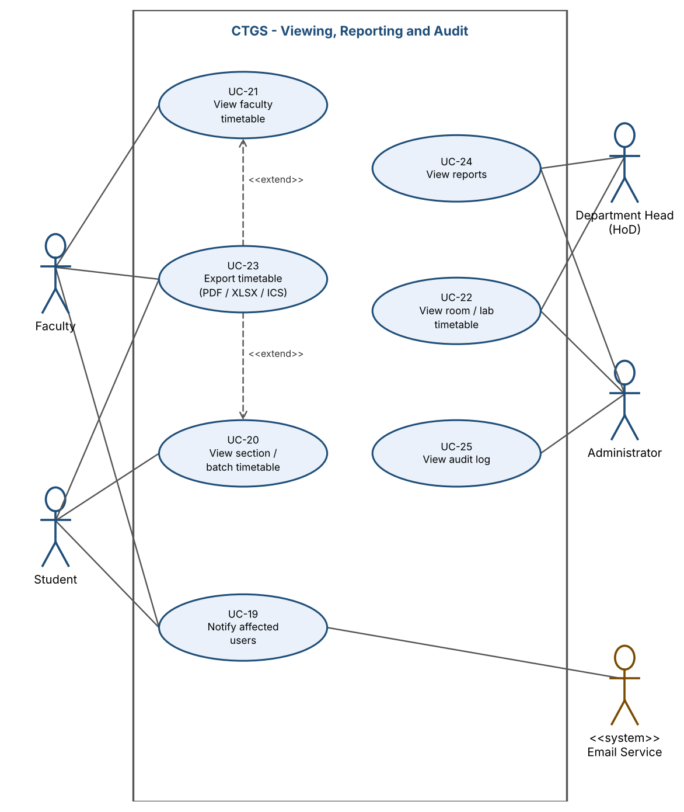
Figure 3: Use-case diagram 3 - Viewing, reporting and audit (UC-19 to UC-25)
Table 5: Use-case catalogue and requirement mapping
Use case | Name | Actors | Requirements
UC-01 | Log in and manage session | All users | F-001, F-002, F-003
UC-02 | Manage users and roles | Administrator | F-004
UC-03 | Manage master data | Administrator, Coordinator | F-010, F-011, F-012, F-013, F-014, F-015
UC-04 | Import data (CSV/XLSX) | Coordinator | F-016
UC-05 | Define teaching assignments | Coordinator | F-017
UC-06 | Configure constraints | Coordinator | F-020, F-021, F-025
UC-07 | Set availability and preferences | Faculty | F-022, F-023
UC-08 | Lock / pre-assign sessions | Coordinator | F-024
UC-09 | Clone term and back up data | Administrator | F-061
UC-10 | Run feasibility check | Coordinator | F-030
UC-11 | Generate timetable | Coordinator; Scheduler Engine | F-031, F-033, F-034, F-035, F-036, F-037, F-038
UC-12 | Validate hard constraints | System (included) | F-032, F-041
UC-13 | Review conflict report | Coordinator | F-041
UC-14 | Edit timetable manually | Coordinator | F-040
UC-15 | Handle faculty / room disruption | Coordinator | F-042
UC-16 | Manage versions (compare / roll back) | Coordinator | F-043
UC-17 | Submit for approval | Coordinator | F-044
UC-18 | Approve and publish | HoD | F-044
UC-19 | Notify affected users | Email Service; recipients Faculty, Student | F-055
UC-20 | View section / batch timetable | Student | F-050
UC-21 | View faculty timetable | Faculty | F-051
UC-22 | View room / lab timetable | Administrator, HoD | F-052
UC-23 | Export timetable (PDF / XLSX / ICS) | Student, Faculty | F-053
UC-24 | View reports | HoD, Administrator | F-054
UC-25 | View audit log | Administrator | F-060

F-nnn abbreviates TT-F-nnn.

8. Requirements Traceability Matrix (RTM)
The RTM links every requirement to the SRS section and design specification (DS ids are defined in the SAD, section 3.8), the implementing module, and the test cases in the Software Test Plan. Status: N = Not started, P = In progress, A = Accepted (implemented and test cases passed). All 62 requirements are covered by at least one of the 79 test cases.
Req ID | Requirement (short) | Section ref / Design Spec | Module | Test case(s) | Status (N/P/A) | Comments
4.1 Authentication and Access Control
TT-F-001 | Authenticate user | 4.1 / DS-Auth-01 | AuthModule | TC-Auth-01, TC-Auth-02 | N | Priority: High
TT-F-002 | Role-based access control | 4.1 / DS-Auth-02 | AuthModule | TC-Auth-03 | N | Priority: High
TT-F-003 | Lockout and session timeout | 4.1 / DS-Auth-01 | AuthModule | TC-Auth-04, TC-Auth-05 | N | Priority: Medium
TT-F-004 | User and role administration | 4.1 / DS-Auth-03 | AuthModule | TC-Auth-06 | N | Priority: Medium
4.2 Master Data Management
TT-F-010 | Academic structure CRUD | 4.2 / DS-Data-01 | MasterDataModule | TC-MD-01 | N | Priority: High
TT-F-011 | Course CRUD | 4.2 / DS-Data-01 | MasterDataModule | TC-MD-02 | N | Priority: High
TT-F-012 | Faculty and qualification CRUD | 4.2 / DS-Data-01 | MasterDataModule | TC-MD-03 | N | Priority: High
TT-F-013 | Room and lab CRUD | 4.2 / DS-Data-01 | MasterDataModule | TC-MD-04 | N | Priority: High
TT-F-014 | Sections and lab batch splitting | 4.2 / DS-Data-02 | MasterDataModule | TC-MD-05, TC-MD-06 | N | Priority: High
TT-F-015 | Time grid configuration | 4.2 / DS-Data-01 | MasterDataModule | TC-MD-07 | N | Priority: High
TT-F-016 | Bulk import with validation | 4.2 / DS-Data-03 | ImportModule | TC-MD-08, TC-MD-09 | N | Priority: High
TT-F-017 | Course offerings and teaching assignments | 4.2 / DS-Data-04 | MasterDataModule | TC-MD-10 | N | Priority: High
4.3 Constraint Configuration
TT-F-020 | Hard constraint catalogue | 4.3 / DS-Cons-01 | ConstraintModule | TC-Con-01 | N | Priority: High
TT-F-021 | Soft constraint weights | 4.3 / DS-Cons-01 | ConstraintModule | TC-Con-02 | N | Priority: Medium
TT-F-022 | Faculty availability and preferences | 4.3 / DS-Cons-02 | ConstraintModule | TC-Con-03 | N | Priority: High
TT-F-023 | Room unavailability | 4.3 / DS-Cons-02 | ConstraintModule | TC-Con-04 | N | Priority: Medium
TT-F-024 | Locked sessions | 4.3 / DS-Cons-03 | ConstraintModule | TC-Con-05 | N | Priority: High
TT-F-025 | Elective groups and combined classes | 4.3 / DS-Cons-04 | ConstraintModule | TC-Con-06 | N | Priority: High
4.4 Timetable Generation
TT-F-030 | Feasibility pre-check | 4.4 / DS-Gen-01 | SchedulerEngine | TC-Gen-01, TC-Gen-02 | N | Priority: High
TT-F-031 | Automatic generation | 4.4 / DS-Gen-03 | SchedulerEngine | TC-Gen-03 | N | Priority: High
TT-F-032 | Zero hard-constraint violations | 4.4 / DS-Gen-03, DS-Val-01 | SchedulerEngine, ValidationModule | TC-Gen-04, TC-Gen-05, TC-Rel-01 | N | Priority: High
TT-F-033 | Lab block scheduling | 4.4 / DS-Gen-04 | SchedulerEngine | TC-Gen-06 | N | Priority: High
TT-F-034 | Soft-constraint optimisation | 4.4 / DS-Gen-05 | SchedulerEngine | TC-Gen-07 | N | Priority: Medium
TT-F-035 | Automatic faculty allocation | 4.4 / DS-Gen-02 | SchedulerEngine | TC-Gen-08 | N | Priority: High
TT-F-036 | Infeasibility diagnosis and partial result | 4.4 / DS-Gen-06 | SchedulerEngine | TC-Gen-09, TC-Gen-10 | N | Priority: High
TT-F-037 | Asynchronous generation job | 4.4 / DS-Gen-07 | SchedulerEngine | TC-Gen-10, TC-Gen-11, TC-Gen-12, TC-Gen-13 | N | Priority: High
TT-F-038 | Regenerate remaining and alternatives | 4.4 / DS-Gen-08 | SchedulerEngine | TC-Gen-14, TC-Gen-15 | N | Priority: Medium
4.5 Conflict Detection, Editing and Publishing
TT-F-040 | Manual edit with conflict check | 4.5 / DS-Edit-01 | TimetableModule | TC-Edit-01, TC-Edit-02, TC-Edit-08 | N | Priority: High
TT-F-041 | Conflict report | 4.5 / DS-Val-01 | ValidationModule | TC-Edit-03 | N | Priority: High
TT-F-042 | Disruption handling | 4.5 / DS-Edit-02 | TimetableModule | TC-Edit-04 | N | Priority: Medium
TT-F-043 | Versioning, compare and rollback | 4.5 / DS-Edit-03 | TimetableModule | TC-Edit-05, TC-Edit-06 | N | Priority: Medium
TT-F-044 | Approval and publish workflow | 4.5 / DS-Edit-04 | TimetableModule | TC-Edit-07 | N | Priority: High
4.6 Views, Reports, Export and Notifications
TT-F-050 | Section / batch view | 4.6 / DS-Rep-01 | ReportModule | TC-View-01 | N | Priority: High
TT-F-051 | Faculty view and load | 4.6 / DS-Rep-01 | ReportModule | TC-View-02 | N | Priority: High
TT-F-052 | Room / lab view | 4.6 / DS-Rep-01 | ReportModule | TC-View-03 | N | Priority: Medium
TT-F-053 | Export PDF / XLSX / ICS | 4.6 / DS-Rep-02 | ReportModule | TC-View-04, TC-View-05 | N | Priority: Medium
TT-F-054 | Reports | 4.6 / DS-Rep-03 | ReportModule | TC-Rep-01 | N | Priority: Medium
TT-F-055 | Publish / change notification | 4.6 / DS-Ntf-01 | NotifyModule | TC-Ntf-01, TC-Ntf-02 | N | Priority: Medium
4.7 Audit and Administration
TT-F-060 | Audit trail | 4.7 / DS-Aud-01 | AuditModule | TC-Aud-01 | N | Priority: High
TT-F-061 | Backup, restore and term cloning | 4.7 / DS-Ops-01 | Platform (Ops) | TC-Aud-02, TC-Aud-03 | N | Priority: Medium
5 Non-functional requirements
TT-NF-001 | Generation time | 5 / DS-Perf-01 | SchedulerEngine | TC-Perf-01, TC-Perf-02 | N | Priority: High
TT-NF-002 | UI / API responsiveness | 5 / DS-Perf-02 | WebUI, API | TC-Perf-03, TC-Perf-04 | N | Priority: High
TT-NF-003 | Zero hard violations (quality) | 5 / DS-Val-01 | ValidationModule | TC-Gen-04, TC-Rel-01 | N | Priority: High
TT-NF-004 | Availability | 5 / DS-Ops-02 | Platform (Ops) | TC-OPS-01 | N | Priority: High
TT-NF-005 | Scalability | 5 / DS-Perf-03 | Platform | TC-Perf-05 | N | Priority: Medium
TT-NF-006 | Usability | 5 / DS-UX-01 | WebUI | TC-UX-01 | N | Priority: Medium
TT-NF-007 | Accessibility | 5 / DS-UX-02 | WebUI | TC-UX-02 | N | Priority: Medium
TT-NF-008 | Reproducibility | 5 / DS-Gen-09 | SchedulerEngine | TC-Gen-12 | N | Priority: Medium
TT-NF-009 | Maintainability | 5 / DS-Arch-01 | All modules | TC-Mnt-01 | N | Priority: Medium
TT-NF-010 | Backup / recovery objectives | 5 / DS-Ops-01 | Platform (Ops) | TC-OPS-02 | N | Priority: High
TT-NF-011 | Browser compatibility | 5 / DS-UX-03 | WebUI | TC-UX-03 | N | Priority: Medium
TT-NF-012 | Audit retention | 5 / DS-Aud-01 | AuditModule | TC-OPS-03 | N | Priority: Medium
5.1.2 Security requirements
TT-SR-001 | TLS 1.2+ everywhere | 5.1.2 / DS-Sec-01 | Platform | TC-Sec-01 | N | Priority: High; SO-1, SO-2
TT-SR-002 | Password storage | 5.1.2 / DS-Sec-02 | AuthModule | TC-Sec-02 | N | Priority: High; SO-1
TT-SR-003 | Server-side authorisation | 5.1.2 / DS-Auth-02 | AuthModule | TC-Auth-03, TC-Sec-03 | N | Priority: High; SO-1, SO-2
TT-SR-004 | Input validation / OWASP Top 10 | 5.1.2 / DS-Sec-03 | API, WebUI | TC-Sec-04 | N | Priority: High; SO-1, SO-2
TT-SR-005 | Session security | 5.1.2 / DS-Auth-01 | AuthModule | TC-Auth-05, TC-Sec-05 | N | Priority: High; SO-1, SO-2
TT-SR-006 | Rate limits and solver quotas | 5.1.2 / DS-Sec-04 | Platform | TC-Sec-06 | N | Priority: High; SO-3
TT-SR-007 | Upload validation | 5.1.2 / DS-Sec-05 | ImportModule | TC-MD-09, TC-Sec-07 | N | Priority: High; SO-1, SO-3
TT-SR-008 | Audit integrity and log hygiene | 5.1.2 / DS-Aud-01 | AuditModule | TC-Aud-01, TC-Sec-08 | N | Priority: High; SO-2
TT-SR-009 | Secrets and dependency hygiene | 5.1.2 / DS-Sec-06 | Platform | TC-Sec-09 | N | Priority: Medium; SO-1, SO-2
TT-SR-010 | Privacy and data minimisation | 5.1.2 / DS-Sec-07 | AuthModule, ReportModule | TC-Sec-03, TC-Sec-10 | N | Priority: High; SO-1

